National University of Computer & Emerging Sciences
Karachi Campus



STUDENT MANAGEMENT SYSTEM
Project Report
Object Oriented Programming
Section: BCS-2E

25k-0925 Vivek Kumar
- Abstract
The Student Management system is a console based software application developed using C++ and Object Oriented Programming (OOP) concepts. The main purpose of this project is to manage student records in an efficient, organized, and automated way. The system allows users to add, display, search, update, and delete student records. It also calculates percentage, assigns grades automatically, and generates statistical reports such as highest marks, lowest marks, class average, pass, and fail ratio.
The project uses important OOP concepts such as classes, objects, inheritance, encapsulation, polymorphism, constructors, destructors, and file handling. Student data is permanently stored in a text file, allowing records to be loaded again whenever the program starts.
This project reduces the problems of manual record keeping such as data loss, time consumption, and human errors. It provides a user friendly menu driven interface and demonstrates the practical implementation of Object Oriented Programming in solving real world management problems.
- Introduction
Student Management System is a console based software application developed in C++ using Object Oriented Programming(OOP) concepts. The purpose of this project is to manage student records efficiently. It store student information such as name, age, roll number, section, subject marks, percentage, and grade.
The system replaces manual record keeping with an automated solution that is faster, more accurate, and easy to maintain.
- Problem Statement
Traditional student record system use register or paper files. These system create many problems:
- Data may be lost or damaged
- Searching records takes too much time
- Updating data is difficult
- Human errors are common
- No automatic results calculation
- No proper organization of records
- Objectives
- The main objective of this project are:
- To store student records digitally
- To add, update, delete, and search student data
- To calculate percentage and grade automatically
- To generate reports and statistics
- To apply OOP concepts in a real project
- To save data permanently using files
- Proposed Solution
A Student Management System developed in C++ using classes and objects. The system provides a menu driven interface where users can perform different operations easily. It also stores records in a text file so data remains available after program restart.
- Tools & Technology
Tool | Usage
C++ | Programming Language
OOP | Programming Paradigm
Dev C++ | Compiler
Windows | Operating System
Text File | Permanent Data Storage

- Code Sniped
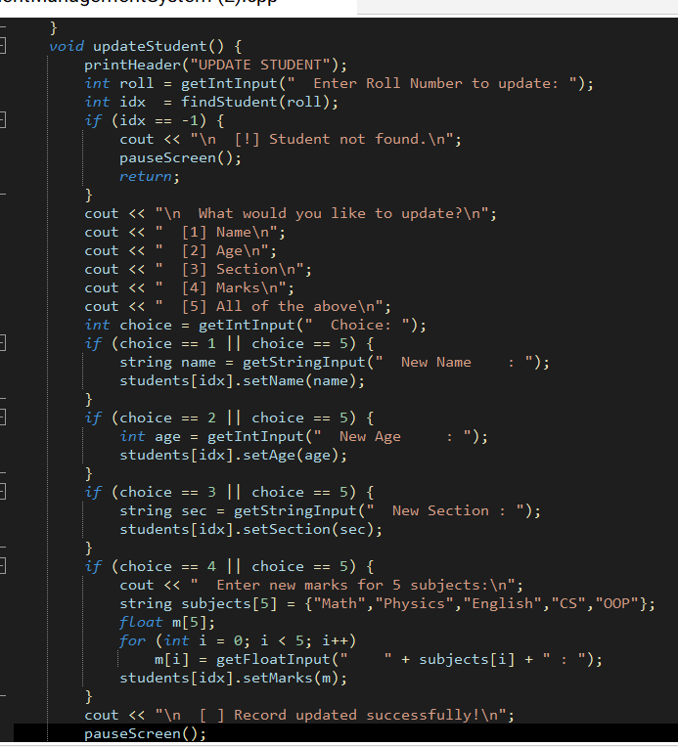

- Sample Output
It is a function of given sniped code
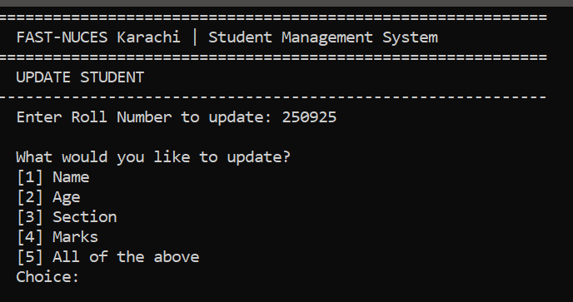
- Advantages
- Easy to use
- Fast searching
- Accurate grade calculation
- Permanent storage
- Reduce paperwork
- Organized records
- Demonstrates OOP Concepts
- Limitations
- Console based interface only
- Single user system
- No login Security
- Uses text file instead of database
- Future Enhancements
- Graphical User Interface(GUI)
- Database integration
- Login system
- Attendance Management
- Fee Management
- Subject wise reports
- Online Portal
- Conclusion
Student Management System is a useful OOP based project developed in C++. It successfully manages student records through automation. The project demonstration important concepts such as inheritance, encapsulation, polymorphism, file handling, and classes. It is efficient, user friendly, and suitable for academic learning.

